







Dashboard
Sprint
Product Backlog, Sprint Schedule, and Estimation (4 Marks)
Sprint-1
High
Project Planning Phase
As a user, I can register for the application
Story Points
Sprint-1
Team ID
High
As a user, I can register for the application by
entering my email, password, and confirming
Sprint-2
Number
High
User Story
Low
Team
Login
5 Marks
As a user, I will receive confirmation email once
28 June 2025
As a user, I can register for the application
my password.
2
USN-1
Sprint-1
through Facebook
2
1
Requirement (Epic)
USN-3
Members
Sprint-1
Functional
2
User Story / Task
through Gmail
Priority
I have registered for the application
Use the below template to create product backlog and sprint schedule
As a user, I can log into the application by
Maximum Marks
USN-2
Project Name
USN-4
Date
1
Project Planning Template (Product Backlog, Sprint Planning, Stories, Story points)
USN-5
entering email & password
Medium
Registration
LTVIP2025TMID28557
Laptop Request Catalog Item









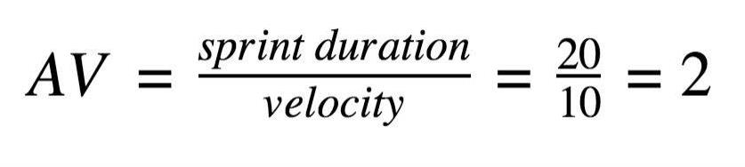
Story Points
29 Oct 2022
Planned End Date)
Points
(Planned)
Completed (as on
(Actual)
Sprint
Total Story
Duration
Sprint Start Date
Sprint End Date
20
Sprint Release Date
Project Tracker, Velocity & Burndown Chart: (4 Marks)
07 Nov 2022
iteration unit (story points per day)
Imagine we have a 10-day sprint duration, and the velocity of the team is 20 (points per sprint). Let’s calculate the team’s average velocity (AV) per
Velocity:
Sprint-4
20
6 Days
14 Nov 2022
19 Nov 2022
Sprint-3
20
6 Days
12 Nov 2022
Sprint-2
20
6 Days
05 Nov 2022
Sprint-1
20
6 Days
24 Oct 2022
29 Oct 2022
31 Oct 2022



https://www.atlassian.com/agile/tutorials/burndown-charts
https://www.atlassian.com/agile/project-management/estimation
https://www.atlassian.com/agile/tutorials/sprints
https://www.atlassian.com/agile/tutorials/epics
https://www.atlassian.com/agile/tutorials/how-to-do-scrum-with-jira-software
https://www.atlassian.com/agile/project-management
Reference:
https://www.atlassian.com/agile/tutorials/burndown-charts
https://www.visual-paradigm.com/scrum/scrum-burndown-chart/
as Scrum. However, burn down charts can be applied to any project containing measurable progress over time.
A burn down chart is a graphical representation of work left to do versus time. It is often used in agile software development methodologies such
Burndown Chart:

Sprint-2
Laptop Request USN-8
As an admin, I can2track all l
Medium
Sprint-2
Laptop Request USN-7
As a manager, I can2 approve or
High
Sprint-2
Laptop Request USN-6
As an employee, I3can request
High
Sprint-1
Login
USN-5
As a user, I can log1 in using
High
Sprint-1
Registration
USN-4
As a user, I can register2 via
Medium
Sprint-2
Registration
USN-3
As a user, I can register2 via
Low
Sprint-1
Registration
USN-2
As a user, I will receive
1
a co
High
Sprint-1
Registration
USN-1
As a user, I can register2 by e
High
Sprint
Functional Requirement
Us r S(Epic)tory NumberUser Story / Task Story Points
Priority
Team Members
Updated Product Backlog Including Laptop Request Catalog Item

